Lymphoedema Study
Patient Information Sheet – Total Procedure Time: 7 hours

Your Appointment
You can write the details of your appointment here:

DATE: _______________

TIME: _______________

Pregnant?
Please tell us if there is a chance you may be pregnant
Please tell us if you are pregnant or breastfeeding

Contact Us
Phone: 6457 2322
Open: Mon-Fri 7:00am-5:00pm.
Sir Charles Gairdner Hospital Nuclear Medicine Department First Floor – Blue Lifts – G Block

Scan Procedure
This imaging procedure is used to assess lymphoedema (swelling) in either the arms or the legs.

Part One Time: 1 hour
You will be given an injection of a radioactive tracer into the webbing between your toes or fingers depending on what site we are looking at. These injections will sting.
As soon as we have given the injections we will take pictures. This takes approximately one hour.

Part Two Time: 30 minutes each
You may be required to return for more imaging at 2 and 6 hours after the first scan. If you are required to return; the pictures will take approximately half an hour each.

Preparation

To come prepared for your scan please:
- Do not wear jewellery to your appointment.
- Do not wear clothes that have metal on them. This includes zippers, buttons and embellishments.
- Bring copies of previous scans with you.

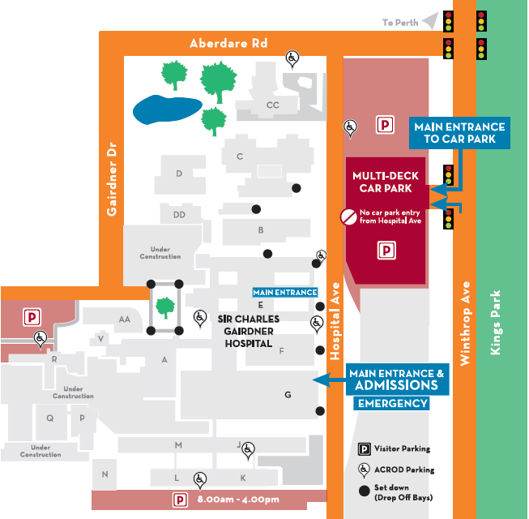
Where To Find Us:
We Are Here:
1st Floor
Blue Lifts
G Block

Sir Charles Gairdner Hospital

Nuclear Medicine Department

First Floor- Blue Lifts – G Block

