Gastric Emptying
Patient Information Sheet – Total Procedure Time: 4.5 hours

Your Appointment
You can write the details of your appointment here:

DATE: _______________

TIME: _______________

Pregnant?
Please tell us if there is a chance you may be pregnant
Please tell us if you are pregnant or breastfeeding

Contact Us
Phone: 6457 2322
Open: Mon-Fri 7:00am-5:00pm.
Sir Charles Gairdner Hospital Nuclear Medicine Department First Floor – Blue Lifts – G Block

Scan Procedure
This study looks at how quickly food is emptied from the stomach. It allows us to assess whether your stomach is emptying at a normal rate. The whole study will take approximately four and a half hours.

Part One – Meal Time: 10 minutes
You will be given scrambled eggs with toast and a cup of water after one of our nurses has taken your blood sugar level via a small finger prick. We ask that you eat all of this meal.

Part Two – Scans Time: 5 minutes each
Each scan will take approximately 5 minutes. We will take your scans at approximately:
- Straight after your meal
- 1 hour after your meal
- 2 hours after your meal
- 4 hours after your meal

Preparation

To come prepared for your scan please:
- If you are diabetic or have special eating requirements please phone us prior to your scan.
- Please do not take any opioids or sedative drugs – contact one of our nurses to discuss any medications you may be taking
- You must fast for 8 hours before your appointment.
- Do not drink alcohol or smoke for 24 hours prior to your appointment.
- Do not wear jewellery to your appointment.
- Do not wear clothes that have metal on them. This includes zippers, buttons and embellishments.
- Bring copies of previous scans with you.

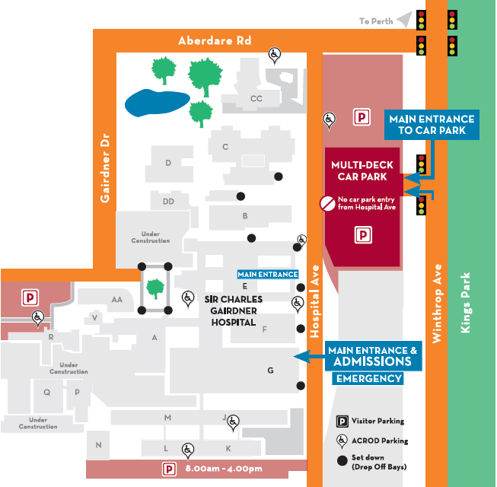
Where To Find Us:
We Are Here:
1st Floor
Blue Lifts
G Block

Sir Charles Gairdner Hospital

Nuclear Medicine Department

First Floor- Blue Lifts – G Block

