Gallium Scan
Patient Information Sheet – Total Procedure Time: 2 days

Your Appointment
You can write the details of your appointment here:

DATE: _______________

TIME: _______________

Pregnant?
Please tell us if there is a chance you may be pregnant
Please tell us if you are pregnant or breastfeeding

Contact Us
Phone: 6457 2322
Open: Mon-Fri 7:00am-5:00pm.
Sir Charles Gairdner Hospital Nuclear Medicine Department First Floor – Blue Lifts – G Block

Scan Procedure
A gallium scan is an imaging procedure used to evaluate infection, inflammation and some tumours. It is performed on two separate appointments usually two days apart.

Day One Time: 15 minutes
You will be given an injection of a radioactive tracer. This appointment takes about 15 minutes.

Day Two Time: 2 hours
Usually two days (or 48 hours) after your injection you will return to the department for a scan. We may take pictures of your whole body or we may focus on a specific part of your body. This scan can take approximately 2 hours in total. You will be required to keep still while the pictures are being taken.

Preparation

To come prepared for your scan please:
- Do not wear jewellery to your appointment.
- Do not wear clothes that have metal on them. This includes zippers, buttons and embellishments.
- Bring copies of previous scans with you.

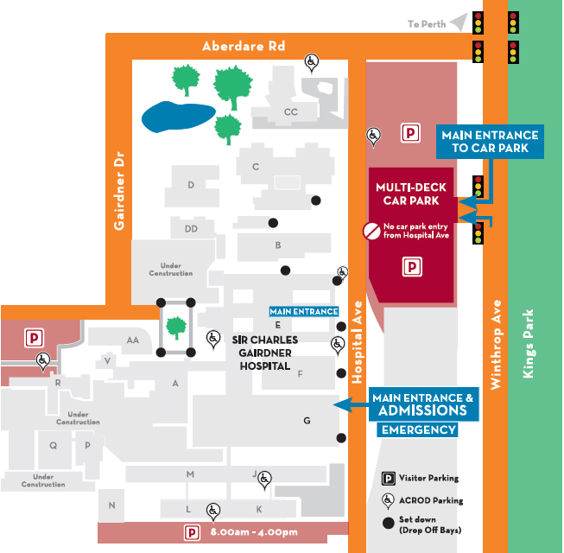
Where To Find Us:
We Are Here:
1st Floor
Blue Lifts
G Block

Sir Charles Gairdner Hospital

Nuclear Medicine Department

First Floor- Blue Lifts – G Block

