DMSA Scan
Patient Information Sheet – Total Procedure Time: 4 hours

Your Appointment
You can write the details of your appointment here:

DATE: _______________

TIME: _______________

Pregnant?
Please tell us if there is a chance you may be pregnant
Please tell us if you are pregnant or breastfeeding

Contact Us
Phone: 6457 2322
Open: Mon-Fri 7:00am-5:00pm.
Sir Charles Gairdner Hospital Nuclear Medicine Department First Floor – Blue Lifts – G Block

Scan Procedure
This scan allows us to look at your kidneys. It shows us the contribution that each kidney makes to your overall renal function. It also allows us to detect scarring of the kidney.

Part One – Injection Time: 15 minutes
You will be given an injection of a radioactive tracer that goes to the kidneys. This takes about 15 minutes.

Break Time: 3 hours
There is a break of 3 hours between the injection and the scan. You are free to leave the department during this time and you may eat and drink.

Part Two – Scan Time 30 minutes
You will return for your scan 3 hours after the injection. The scan will take approximately half an hour. You will be required to lie still as we take pictures of your kidneys.

Preparation

To come prepared for your scan please:
- Do not wear jewellery to your appointment.
- Do not wear clothes that have metal on them. This includes zippers, buttons and embellishments.
- Bring copies of previous scans with you.

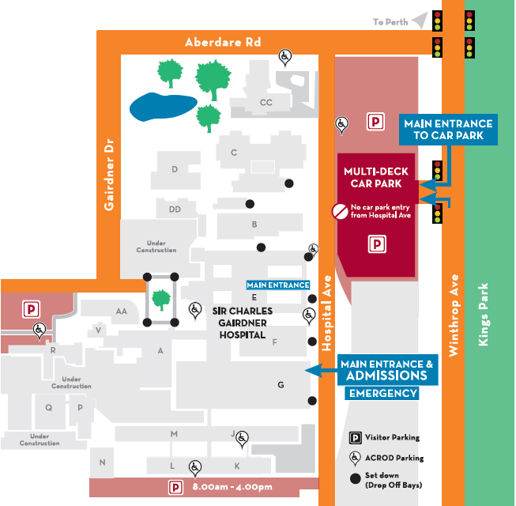
Where To Find Us:
We Are Here:
1st Floor
Blue Lifts
G Block

Sir Charles Gairdner Hospital

Nuclear Medicine Department

First Floor- Blue Lifts – G Block

