Brain Scan
Patient Information Sheet – Total Procedure Time: 3 hours

Your Appointment
You can write the details of your appointment here:

DATE: _______________

TIME: _______________

Pregnant?
Please tell us if there is a chance you may be pregnant
Please tell us if you are pregnant or breastfeeding

Contact Us
Phone: 6457 2322
Open: Mon-Fri 7:00am-5:00pm.
Sir Charles Gairdner Hospital Nuclear Medicine Department First Floor – Blue Lifts – G Block

Scan Procedure
This test looks at the blood supply to different parts of your brain. It can be used to assess dementia and epilepsy.
The procedure takes about 3 hours.

Injection Time: 45 minutes
We will insert a canula (drip) into a vein in your arm. You will then be asked to rest quietly in a bed in a private room. After 20 minutes a nurse will enter the room and give you an injection through the canula without disturbing you. 10 minutes after the injection the nurse will return to remove the canula and you will be asked to sit back at reception.

Break Time: 45 minutes
You will have to wait approximately 45 minutes between the injection and the scan.

Scan Time: 45 minutes
The scan will take approximately 45 minutes. During the scan the camera will move around your head taking pictures of your brain. It is important not to move your head at all during the scan or we will repeat the imaging.

Preparation

To come prepared for your scan please:
- Avoid caffeine and alcohol on the day of your scan.
- Do not wear jewellery to your appointment.
- Bring copies of previous scans with you.

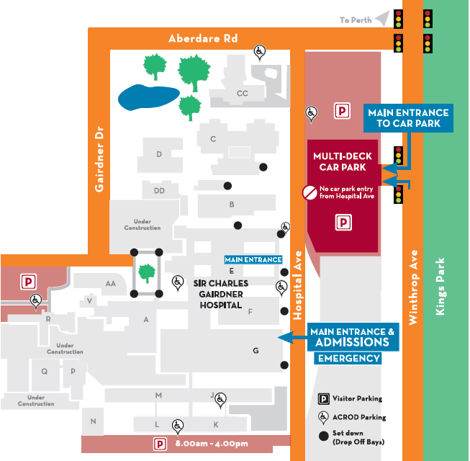
Where To Find Us:
We Are Here:
1st Floor
Blue Lifts
G Block

Sir Charles Gairdner Hospital

Nuclear Medicine Department

First Floor- Blue Lifts – G Block

