Sir Charles Gairdner Hospital
Referral to: MULTIDISCIPLINARY FOOT ULCER CLINIC

DATE

CLIENT DETAILS (use patient sticker if available)
Given Names: Surname:
Date of Birth:
Address: Postcode:
Phone Home: Work: Mobile:
Hospital Unit Medical Record Number (if known):
Medicare Number: expiry date:

MEDICAL HISTORY
☐T1DM ☐T2DM ☐PAD ☐IHD ☐CRF ☐Dialysis ☐Peripheral Neuropathy
Smoking status (current/past/never):
Diabetes duration (if applicable):

Any known allergies:

Current medication (attach medication list):
Prior imaging (attach results):

Height: Weight: BMI:

REASON FOR REFERRAL
☐Foot Ulcer ☐Suspected Charcot Foot ☐Other (please provide detail below)
☐Recurrent Ulcer
Brief description of main concern:

DURATION ☐<4 weeks ☐4 – 12 weeks ☐>3 months
FOOT PULSES – tick if palpable
Right DP PT Left DP PT
CURRENT TREATMENT
Wound Care_______________________________________________________________
Antibiotics_________________________________________________________________
Offloading_________________________________________________________________
Other:____________________________________________________________________

Please indicate areas of concern on foot diagram:

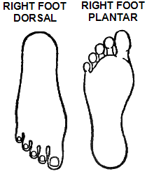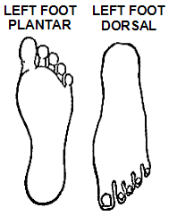

MEDICAL/SURGICAL SPECIALISTS
(Name, specialty, public/private, current involvement, date of last & next appointment)

REFERRAL SOURCE DETAILS GENERAL PRACTITIONER
Name: GP:
Provider #:
Title/Designation: Practice:
Practice:
Phone Number: Phone Number:
Fax: Fax:

Fax to Central Referrals 1300 365 056
Please address any written referrals to the ‘Multidisciplinary Foot Ulcer Clinic’

For inter hospital transfers, please fax the referral directly to the Podiatry Department
Fax: 6457 1568

For any urgent referrals (need to be seen in less than seven days) – please contact the on-duty Vascular Registrar via switchboard.

All other queries can be directed to the SCGH Multidisciplinary Foot Ulcer Clinic Phone: 6457 3373 Fax: 6457 1568

Please Attach All Relevant Investigations, Reports & Results

REFERRAL ELIGIBILITY

Outpatient with complex medical needs presenting with either:

- Foot ulcer, duration > 4 weeks
- Foot infection

which is static or deteriorating OR not responding to best practice

Reason for referral:
  - Unclear aetiology of ulcer
  - Suspected or confirmed osteomyelitis
  - Suspected or confirmed PAD including dry stable necrosis

OR

Suspected or confirmed active Charcot foot:

- hot, red swollen foot
- in the presence of peripheral neuropathy with
- minimal or no reported trauma / progressing deformity

For urgent referrals – patients with acute symptoms such as ascending cellulitis please refer direct to the closest emergency department

